Jordan Bourn

Schadre Dent

Coding Temple: Self-Paced Data Analytics

8/23/2023

### **Capstone I Project Report**

### Research and Analysis of Electric Vehicle Population Data

I chose to look into the Electric Vehicle Population Data provided by the State of Washington, available on data.gov. The dataset consists of just under 144,000 EVs registered through the Washington State Department of Licensing (DOL). I am interested in the growing popularity and environmental impact of electric vehicles so I felt it could be an interesting dataset to analyze.

My hypothesis was; There are more electric vehicles (EVs) registered in Seattle than in any other city in Washington State. I decided to begin my exploration of the dataset in Python. I initially wanted to see if the data was noticeably skewed towards Seattle’s population; I created a function to determine whether a vehicle was registered in Seattle (true) or registered elsewhere than Seattle (false). There are not more EVs registered in Seattle than every other city combined (in and out of Washington State).

From there, to get a better idea of the data, I found all of the cities in Washington State with EVs registered in this dataset. The dataset includes points from 456 cities in Washington State. This is too many cities to show in a pie chart and have it be legible. I next determined all of the counties with registered EVs, and easily found that King county does have the most registered EVs of any county in Washington. Seattle is located in King county, so that is a good indicator that the Seattle area certainly has the most registered EVs. Once I had parsed down the data to only EVs registered in King county Washington I sorted the data by the number of EVs by the city they are registered in.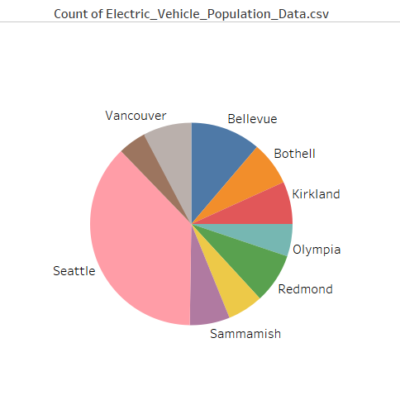

I found that my hypothesis was correct. More EVs are registered in Seattle than in any other city in Washington State. Seattle has the most EVs with 24,662 registered EVs, which is significantly more than the city with the second most recorded EVs; which is Bellevue with 7,375. From an economic and financial standpoint, you can safely assume that installation of EV charging stations and advertising for EVs is more likely to be successful in Seattle than in any other Washington Cities. From a marketing standpoint it could be helpful to better understand the demographics of EV owners and therefore better understand how to, hopefully, better market EVs elsewhere in the state and country. While I could have found this in fewer steps (which I do demonstrate in my attached work), taking the time to break down the data in this way gave me a better understanding of the greater distribution of EVs in this dataset. Not only are there more EVs registered specifically in Seattle, but the Seattle area has the greatest concentration of EVs in the entire state.

### Make and Model

While knowing which city in Washington has more registered EVs is all well and good, there is a lot more information to understand about this dataset. Out of personal curiosity I was interested in knowing which Make and Model of EV is most popular amongst this dataset. I could easily determine that Tesla makes the two most popular models, the Model 3 and the Model Y, by a longshot. There are over 26,000 of each model represented in this data. The Nissan LEAF beats out the Tesla Model S as the third most popular EV. Since I already had the data sorted by make and model I decided to take a look at the least popular models. The three least popular models were the Porsche 918, Chevrolet S-10 Pickup, and Bentley Flying Spur. Each model was only registered once.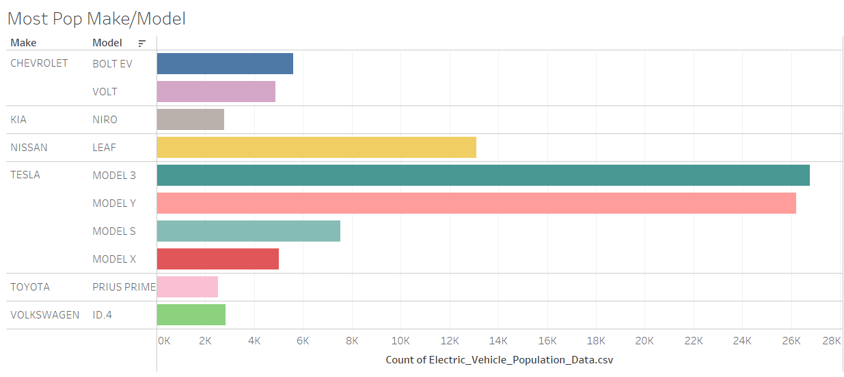

Knowing that all of the Tesla and Nissan models are Battery Electric Vehicles (BEV) while the Porsche 918 and Bentley Flying Spur are Plug-in Hybrid Electric Vehicles (PHEV), I then wanted to know if BEVs are a more popular choice than PHEVs. I grouped the data by the EV type and found the count for each group. This confirmed that there are approximately 100,000 more registered BEVs than PHEVs; that is more than twice as many BEVs on the road than PHEVs.

### BEVs vs PHEVs

Considering reasons that people are purchasing EVs, the environmental impact (or the reduction of) is the first that comes to mind. Comparing BEVs and PHEVs, nearly all BEVs with available battery range data qualify as a Clean Alternative Fuel Vehicle - while less than half of the PHEVs qualify. The electric range (the range a vehicle can travel on one charge) is what determines their eligibility so I took a look at that next. The average electric range of BEVs is 194 miles, with the top of the range being 337 miles and the low being only 29 miles. The average electric range of a PHEV is only 30 miles, with the top and bottom of the range being 153 and just 6 miles. The average PHEV can only travel as far as the lowest range BEVs.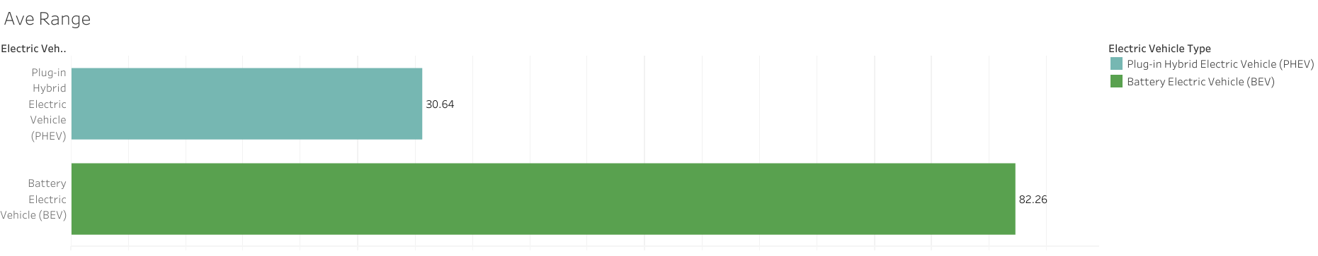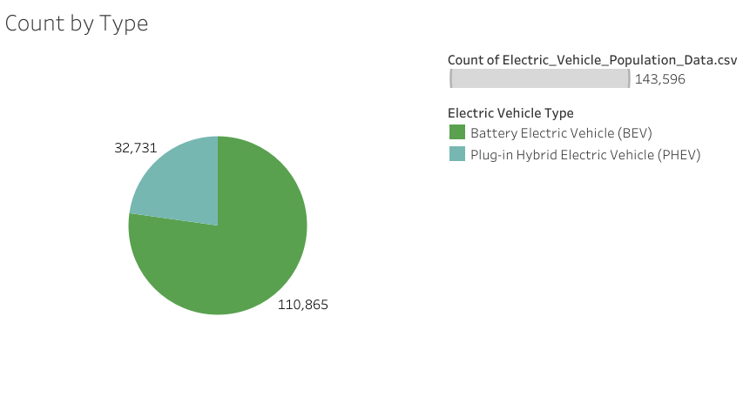

For my next query I decided to look at the dataset in RStudio. As much as environmental impact does play a part in choosing to purchase an EV or not, price can play an equal if not larger role in the decision. This particular dataset has a limited amount of data on the base MSRP of the EVs listed, which I assume has to do with the price variability of cars in general. Nonetheless it seemed like it could be interesting to look at, especially understanding the significant majority Tesla models have. I found that on average the base MSRP of EVs is just over $57,200. To me this seemed like a very high average for the base MSRP.

### Price

I decided to graph the base MSRP of each vehicle make to get a better visual of the spread of data. It became immediately apparent that the average was possibly being skewed by the high price of Porsche models. Excluding the Porsche models altogether, I found the average base MSRP was about $1,200 less. It’s important to note, but not entirely significant when considering the price of a car. Now I was more interested in seeing if the average was being significantly affected by the amount of Tesla models. I excluded the Tesla models from my dataset and calculated the average base MSRP again. Without Tesla’s, the average base MSRP is just under $46,000. That is more than a $11,000 difference from the average with Tesla models included. That is significant. Now knowing that most of the EVs recorded in this data are Tesla models, it’s clear that when drivers are considering purchasing an EV they’re willing to spend more money to get a BEV.

### Conclusion

From my beginning hypothesis that more electric vehicles are registered in Seattle than in other cities in Washington State, to my queries about base MSRP; the Electric Vehicle Population Data taught me a considerable amount about who is purchasing EVs. My research into this dataset showed me that where you live absolutely plays a role in the popularity and presence of EVs. Though this information was collected by Washington State, it can be useful in better understanding the market for EVs and would suggest that the City of Seattle electric utility could have insight into what electric utility providers can expect with an increase of EVs.